附件一
桃園市富岡國小(109)學年度第(2)學期課
後社團活動授課內容計畫書
◎授課教師： 羅少媚
社團  名稱 | 創意卡通造型氣球 |  |  | 指定學生年級 | 一~六 |  |  | 上課  人數 | (10)人開課  (20)人額滿 | 上課地點 |  | 一般教室
上課日 |  | 星期【三】(1300-1430) |  | 課程要求  1、請詳細說明  2、125字以內 |  | 從基礎入手，明確的教授氣球每一種結的扭法，以及不同氣球相互搭配的效果。尤其以時下最受小朋友喜愛的卡通發想，讓所有的造型都能在腦海中轉換後做出來。
教材或其他額外收費 |  | 總費用:2600元  (包含材料費1000 元)
上課  週次或堂次 |  | 進度表  授課內容簡述 | 備註 |  | 上課  週次或堂次 |  | 進度表  授課內容簡述 |  |  |  | 備註
1 |  | 基本技法  之  第一節課就教你頑皮豹 |  |  | 9 |  | 陸地生物  之  熊熊的世界 |  |  |  | 
2 |  | 陸地生物  之  小蝸快走 |  |  | 10 |  | 動漫世界  之  我只要和平 |  |  |  | 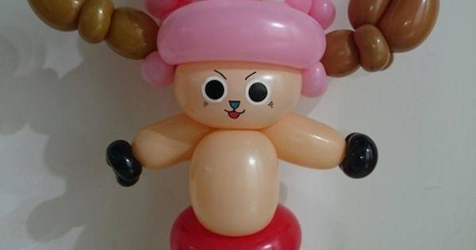  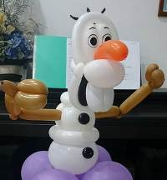
3 |  | 飛行生物  之  飛不飛都是學問 |  |  | 11 |  | 迪士尼世界  之  冷冷冷冷冷
4 |  | 植物  之  花花與瓜瓜 | 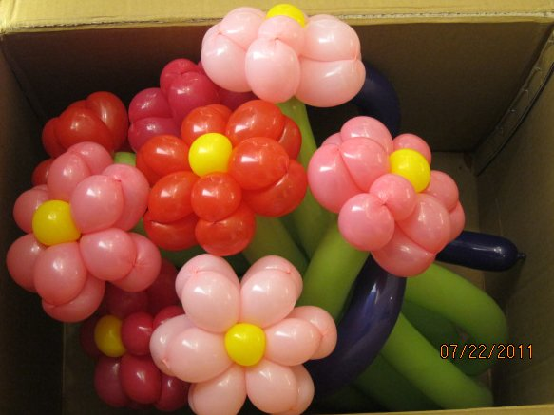 |  | 12 |  | 飛行生物  之  憤怒鳥家族 |  |  |  | 
5 |  | 武器大觀  之  沒有最厲害只有更厲害 |  |  | 13 |  | LINE貼圖  之  動物篇 |  |  |  | 
6 |  | 陸地生物  之  家禽類 | 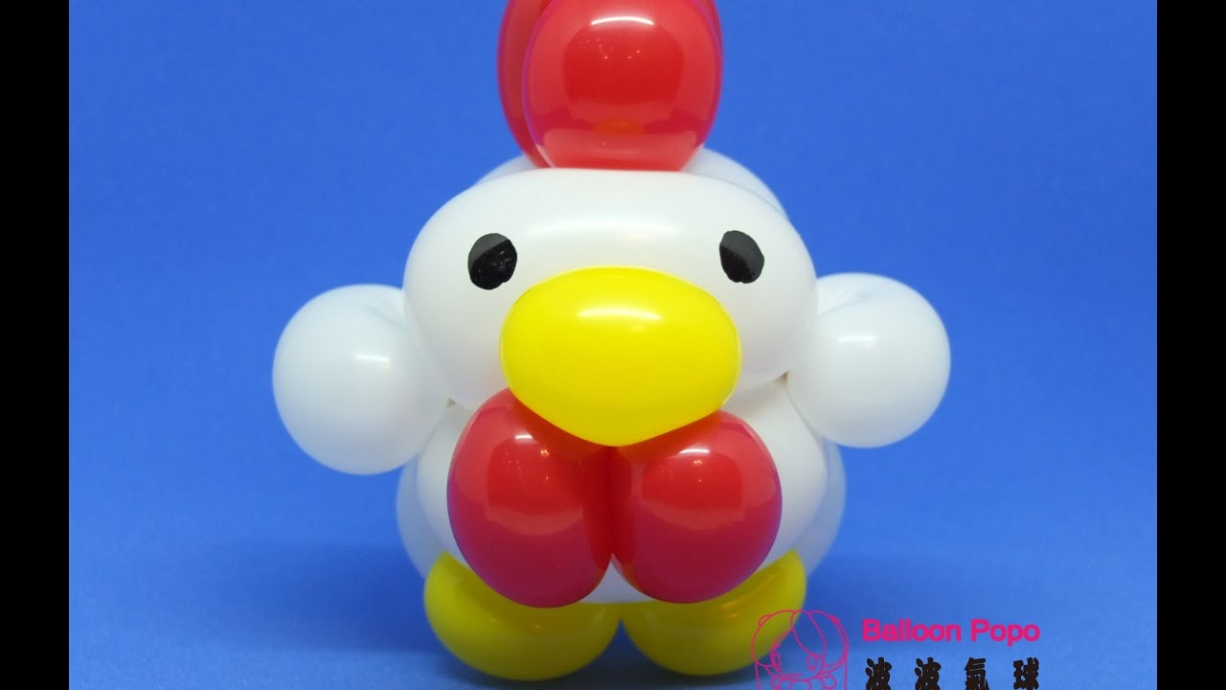 |  | 14 |  | 迪士尼世界  之冷冷冷冷冷 |  |  |  | 
7 |  | 昆蟲類  之  可愛到受不了 | 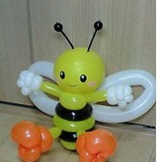 |  | 15 |  | 正義聯盟  之英雄特攻隊 |  |  |  | 
8 |  | 派對首選  之  俏皮美樂蒂 | INCLUDEPICTURE "http://www.saysay.net/data/news/image/201512/20151230_145124_71224.jpg" \* MERGEFORMATINET INCLUDEPICTURE "http://www.saysay.net/data/news/image/201512/20151230_145124_71224.jpg" \* MERGEFORMATINET INCLUDEPICTURE "http://www.saysay.net/data/news/image/201512/20151230_145124_71224.jpg" \* MERGEFORMATINET INCLUDEPICTURE "http://www.saysay.net/data/news/image/201512/20151230_145124_71224.jpg" \* MERGEFORMATINET INCLUDEPICTURE "http://www.saysay.net/data/news/image/201512/20151230_145124_71224.jpg" \* MERGEFORMATINET INCLUDEPICTURE "http://www.saysay.net/data/news/image/201512/20151230_145124_71224.jpg" \* MERGEFORMATINET INCLUDEPICTURE "http://www.saysay.net/data/news/image/201512/20151230_145124_71224.jpg" \* MERGEFORMATINET INCLUDEPICTURE "http://www.saysay.net/data/news/image/201512/20151230_145124_71224.jpg" \* MERGEFORMATINET INCLUDEPICTURE "http://www.saysay.net/data/news/image/201512/20151230_145124_71224.jpg" \* MERGEFORMATINET INCLUDEPICTURE "http://www.saysay.net/data/news/image/201512/20151230_145124_71224.jpg" \* MERGEFORMATINET INCLUDEPICTURE "http://www.saysay.net/data/news/image/201512/20151230_145124_71224.jpg" \* MERGEFORMATINET INCLUDEPICTURE "http://www.saysay.net/data/news/image/201512/20151230_145124_71224.jpg" \* MERGEFORMATINET INCLUDEPICTURE "http://www.saysay.net/data/news/image/201512/20151230_145124_71224.jpg" \* MERGEFORMATINET INCLUDEPICTURE "http://www.saysay.net/data/news/image/201512/20151230_145124_71224.jpg" \* MERGEFORMATINET INCLUDEPICTURE "http://www.saysay.net/data/news/image/201512/20151230_145124_71224.jpg" \* MERGEFORMATINET INCLUDEPICTURE "http://www.saysay.net/data/news/image/201512/20151230_145124_71224.jpg" \* MERGEFORMATINET INCLUDEPICTURE "http://www.saysay.net/data/news/image/201512/20151230_145124_71224.jpg" \* MERGEFORMATINET INCLUDEPICTURE "http://www.saysay.net/data/news/image/201512/20151230_145124_71224.jpg" \* MERGEFORMATINET INCLUDEPICTURE "http://www.saysay.net/data/news/image/201512/20151230_145124_71224.jpg" \* MERGEFORMATINET INCLUDEPICTURE "http://www.saysay.net/data/news/image/201512/20151230_145124_71224.jpg" \* MERGEFORMATINET INCLUDEPICTURE "http://www.saysay.net/data/news/image/201512/20151230_145124_71224.jpg" \* MERGEFORMATINET INCLUDEPICTURE "http://www.saysay.net/data/news/image/201512/20151230_145124_71224.jpg" \* MERGEFORMATINET INCLUDEPICTURE "http://www.saysay.net/data/news/image/201512/20151230_145124_71224.jpg" \* MERGEFORMATINET 

